**CONSOLE BASED COURSE MANAGEMENT SYSTEM**

**OBJECTIVE**:  
 To develop a console-based course management system with java by integrating it with the database using JDBC connectivity.

**Identification of Need:**

Course Management System (CMS) is essential for schools and all other course providers to store the data and retrieve the information about the course, students and schedules very efficiently. CMS is can

**Platform Specifications:**

**Hardware:**

* Intel core i3, i5, i7, i9 or MAC
* minimum 4GB RAM.

**Software:**

* JAVA
* MySQL
* JDBC

**Functional Requirements**

**Course Management**

* Add/ Remove /Update course information
* Store the scheduling of courses
* Manage different level of courses

**Student Management**

* Add / Remove student information who can enroll in courses
* Update student information who can enroll in courses

**Registration table**

* Store the information of enrollment

**Database Operations**

* CRUD operations for records
* Store student and course data
* Ensure data integrity

**Reporting**

* Generate report of course registration data

**SCHEMA DESIGN:**

**STUDENTS**

* student_id (INT, Primary Key, Auto Increment)
* first_name (VARCHAR(100))
* last_name (VARCHAR(100))
* email (VARCHAR(100))
* phone_number (VARCHAR(15))
* registration_date (DATETIME, Default CURRENT_TIMESTAMP)

**COURSES**

* course_id (INT, Primary Key, Auto Increment)
* course_name (VARCHAR(100))
* course_description (VARCHAR(255))
* credits (INT)
* level_id (INT, Foreign Key references COURSELEVELS(level_id))
* schedule (VARCHAR(255))
* max_capacity (INT)

**REGISTRATIONS**

* registration_id (INT, Primary Key, Auto Increment)
* student_id (INT, Foreign Key references STUDENTS(student_id))
* course_id (INT, Foreign Key references COURSES(course_id))
* registration_date (DATETIME, Default CURRENT_TIMESTAMP)
* status (VARCHAR(50))

**COURSELEVELS**

* level_id (INT, Primary Key, Auto Increment)
* level_name (VARCHAR(50))
* requirements (VARCHAR(255))

**COURSESCHEDULES**

* schedule_id (INT, Primary Key, Auto Increment)
* course_id (INT, Foreign Key references COURSES(course_id))
* day_of_week (VARCHAR(20))
* start_time (TIME)
* end_time (TIME)

**SCHEMA DIAGRAM:**

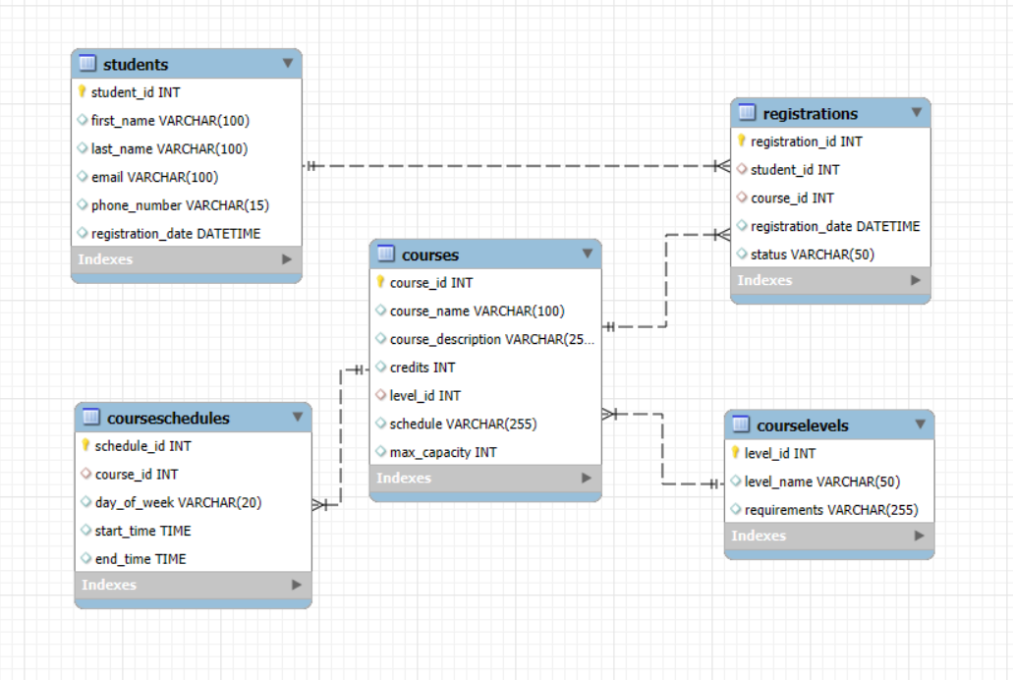

**USE CASE DIAGRAM :**

**USE CASE DIAGRAM FOR COURSE MANAGEMENT SYSTEM**

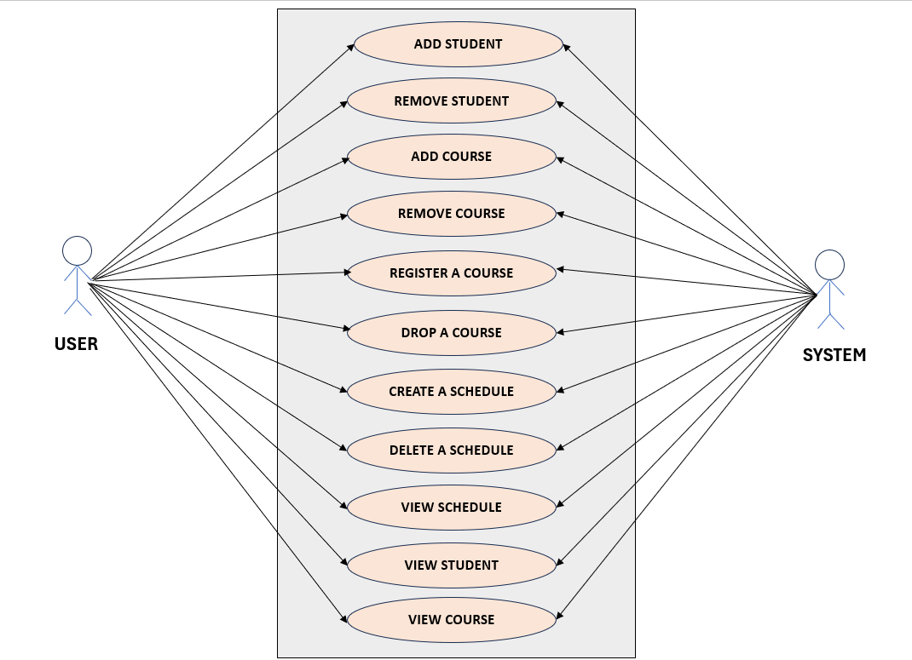

**ENTITY RELATIONSHIP DIAGRAM:**

